Gmail User Registration

User Manual
Version: 1.0

Table of Contents
1. Introduction 3
2. Intended Audience 3
3. Prerequisites 3
4. Gmail Account Registration Procedure 3
4.1 Open Gmail Website 3
4.2 Select Create Account 3
4.3 Enter Personal Information 3
4.4 Write Basic Information 3
4.5 Select Email Address 4
4.6 Create Password 4
4.7 Verify Information 4
4.8 Verify Phone Number 4
4.9 Add Recovery Email 4
4.10 Review Account Information 4
4.11 Accept Terms and Condition 4
4.12 Your Gmail Account is Created 4

Introduction
This user manual provides step by step instructions for new users to create a Gmail account

Intended Audience
This manual is intended for:
- First time Gmail users
- Students and professionals
- Non-technical and beginner users

Prerequisites
Before starting the registration process, ensure you have;
- A stable internet connection
- Computer, laptop, or smart phone
- A valid mobile number for verification
- A web browser (Chrome, Firefox, Safari or Edge)

Gmail Account Registration Procedure

Accessing Gmail Website
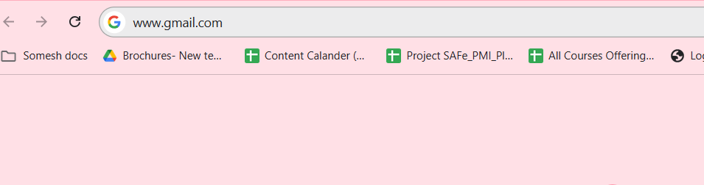
Figure 1 Accessing Gmail Website
- Open a web browser
- Type the following URL in the address bar: https://www.gmail.com
- Press Enter.

Create New Gmail Account
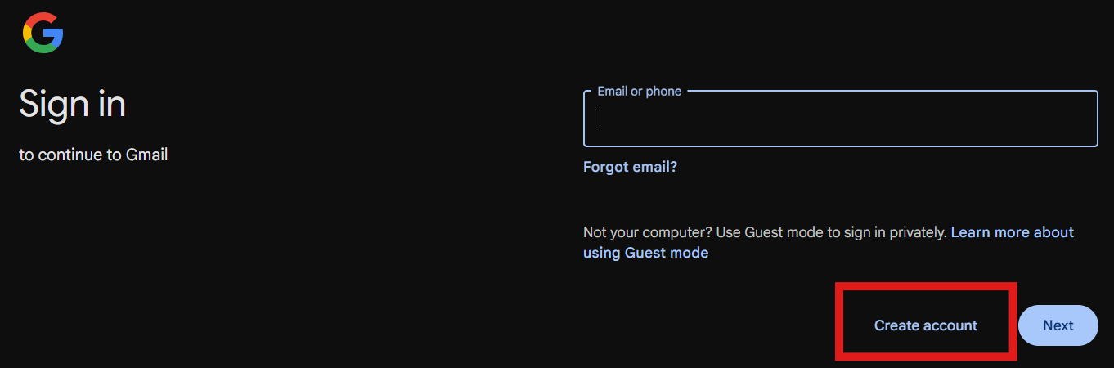
Figure 2: Create New Gmail account
- On Gmail sign-in page, click Create Account
- Choose one of the following options:
  - For myself
  - For my child
  - For work or business

Enter Personal Information
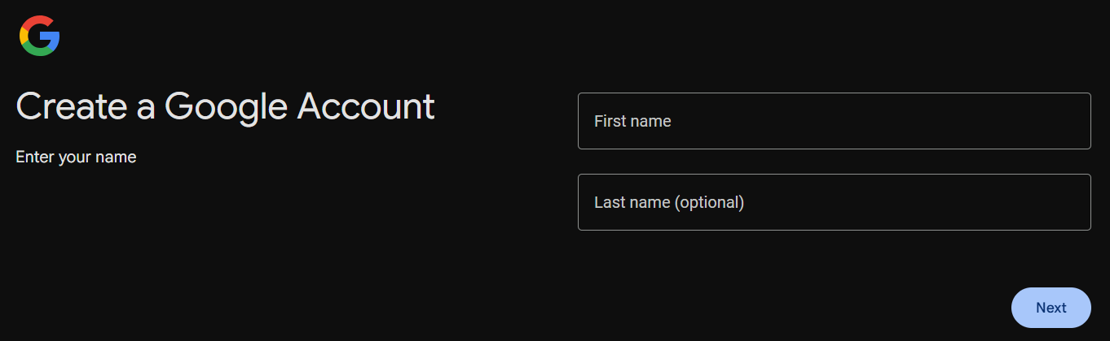
Figure 3: Enter Personal details
- On account creation page
- Type your first name
- Type your last name
- Click next

Write Basic Information
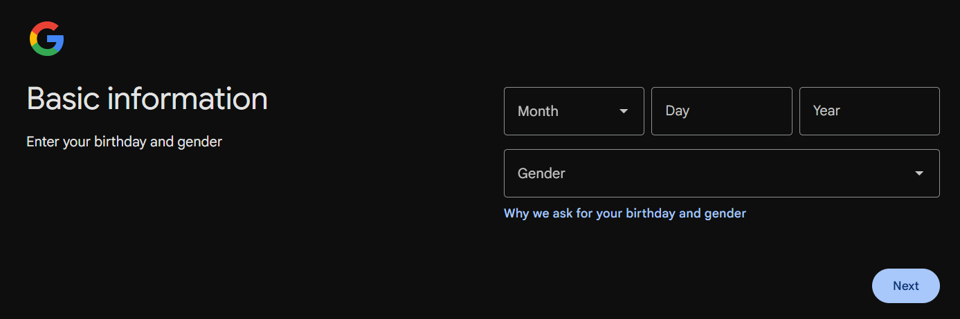
Figure 4: Write basic Information
- Select birthday month
- Write birth date
- Write your year of birth
- Enter your gender male/female/custom/rather not to say
- Click next

Select Email Address
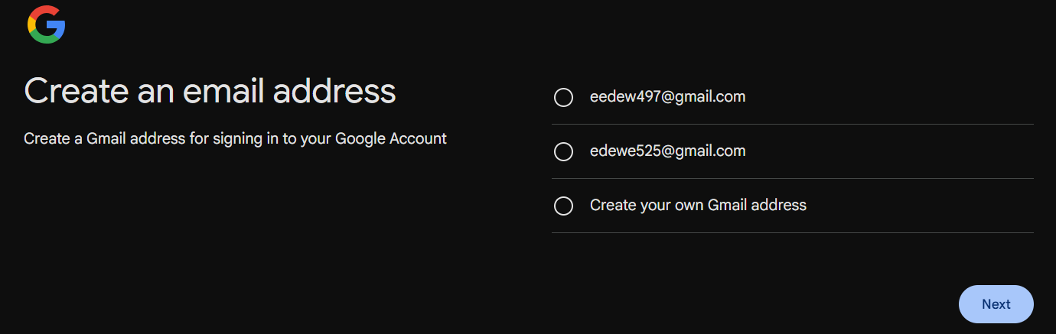
- Select the given email address
Or
- Customise your email address
- Click Next

Create Password
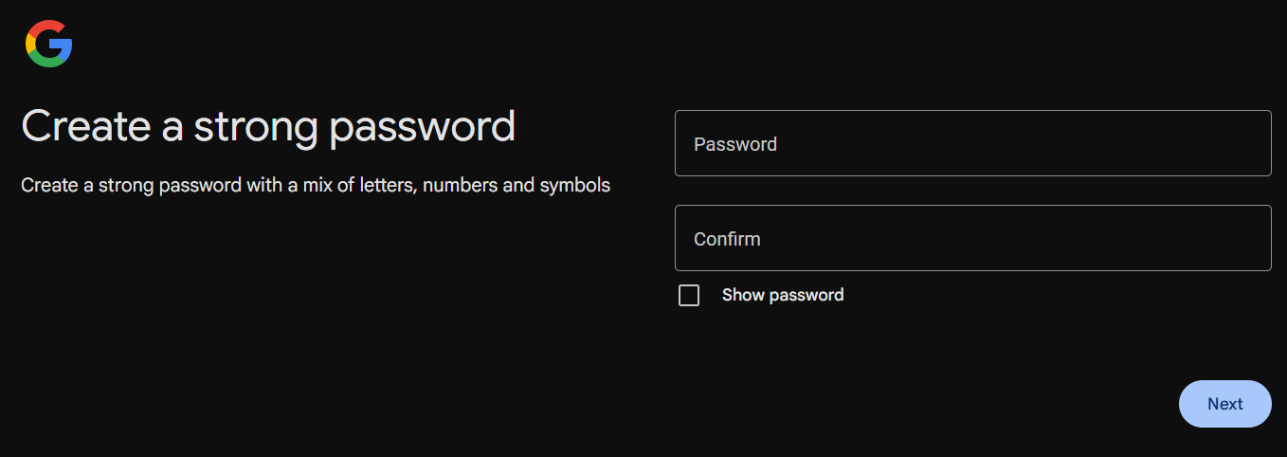
- Type password, ensure it should be mix of letters, numbers and symbols
- Type confirm password
- Click Next

Verify Information
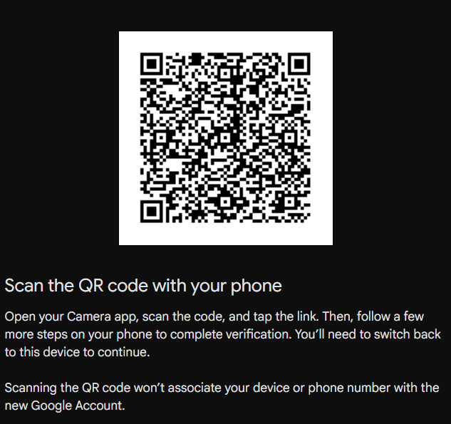
- Open camera on phone
- Scan QR code given on the screen
- Tap on the link

Verify Phone Number
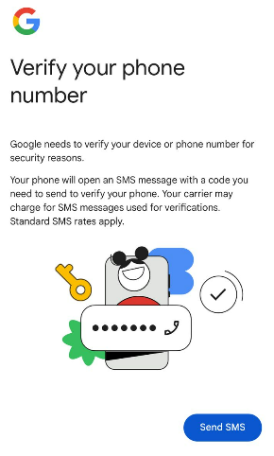
Figure 5: verify phone number
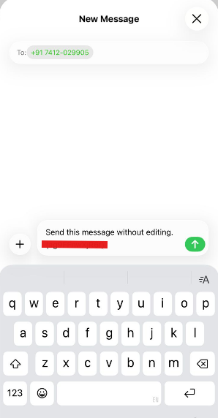
Figure 6: send sms
- Click “Send SMS”
- Google sent a text message on your phone “send this message without editing (XRrixxxxxx)”
- Tap on send

Add Recovery Email
- Add recovery email
- You can either skip this step
- Click Next

4.10 Review Account Information
- Check or verify your email address
- Click Next

4.11 Accept Terms and Condition
- Read Terms and Condition
- Click “I agree”

4.12 Your Gmail Account is Created

Figure 1 Accessing Gmail Website 3
Figure 2: Create New Gmail account 3
Figure 3: Enter Personal details 4
Figure 4: Write basic Information 4
Figure 5: verify phone number 5
Figure 6: send sms 5

